VISVESVARAYATECHNOLOGICALUNIVERSITY
"Jnana Sangama", Belgavi-590018, Karnataka, India


A MINI PROJECT SYNOPSIS
On

“Comparison Of Multiple Algorithms For Stock Price

Prediction Based On Accuracy”
Submitted in Partial Fulfillment of the requirements of 5th Semester

BACHELOR OF ENGINEERING
IN

ARTIFICIAL INTELLIGENCE AND DATA SCIENCE
Submitted By

S Bhavya Sree 1SJ23AD051

K Chandra Priya 1SJ23AD021

Pallavi B Gowda 1SJ23AD035

M Gagana Sree 1SJ23AD028
Under the guidance of
Prof. Darshan A
Assistant Professor
Dept. of AI & DS


DEPARTMENT OF ARTIFICIAL INTELLIGENCE AND DATA SCIENCE

SJC INSTITUTE OF TECHNOLOGY
CHIKKABALLAPUR-562101

2025-2026

||Jai Sri Gurudev||
Sri Adichunchanagiri Shikshana Trust®
SJC INSTITUTE OF TECHNOLOGY, Chickballapur-562101
Department of Artificial Intelligence and Data Science

CERTIFICATE
This is to certify that the mini project work entitled “COMPARISON OF MULTIPLE ALGORITHMS FOR STOCK PRICE PREDICTION BASED ON ACCURACY” is a bonafied work carried out by S Bhavya Sree (1SJ23AD051), K Chandra Priya (1SJ23AD021), Pallavi B Gowda (1SJ23AD035), M Gagana Sree (1SJ23AD028) in partial fulfillment for the award of Bachelor of Engineering in Artificial Intelligence and Data Science of Visvesvaraya Technological University, Belagavi during the year 2025-2026. It is certified that all corrections/suggestions indicated for internal assessment have been incorporated in the report. The mini project report has been approved as it satisfies the academic requirements with respect to mini project work prescribed for the Bachelor of Engineering degree.

…............................  Prof. DARSHAN A  Assistant Professor,  Dept. of AI&DS, SJCIT | ………………………  Prof. SUNIL NAIDU G N  Assistant Professor,  Dept. of AI&DS, SJCIT | ………………....  Dr. NAGARAJA G  Prof. & Head AI&DS  Dept. of AI&DS, SJCIT

DECLARATION

We S Bhavya Sree (1SJ23AD051), K Chandra Priya (1SJ23AD021), Pallavi B Gowda (1SJ23AD035), M Gagana Sree (1SJ23AD028) Students of V semester B.E in ARTIFICIAL INTELLIGENCE AND DATA SCIENCE at S J C Institute of Technology, Chickballapur, hereby declare that this work entitled “COMPARISON OF MULTIPLE ALGORITHMS FOR STOCK PRICE PREDICTION BASED ON ACCURACY” has been carried out at Dept. of AI&DS, SJCIT under the guidance of Prof. Darshan A, Assistant Professor, Dept. of AI&DS, SJC Institute of Technology, Chikkballapur and submitted during the academic year 2025-2026. We further declare that the report had not been submitted to another university for the award of any other degree.

Place: Chickballapur  Date: | S Bhavya Sree 1SJ23AD051  K Chandra Priya 1SJ23AD021  Pallavi B Gowda 1SJ23AD035  M Gagana Sree 1SJ23AD028

ABSTRACT

Stock price prediction has become an essential research area due to the rapid growth of financial markets and the increasing need for intelligent decision-making tools. This project focuses on developing a predictive system that analyzes historical stock market data and forecasts future stock prices using multiple machine learning algorithms. The aim is to compare the performance of different models and identify the most accurate approach for time-series forecasting.

In this research, a dataset containing historical stock prices in CSV format is loaded, cleaned, and preprocessed using Pandas and NumPy. Important steps such as handling missing values, feature extraction, normalization, and splitting the dataset into training and testing sets are performed. Multiple regression-based and time-series models—including Linear Regression, Random Forest Regressor, LSTM (Long Short-Term Memory), and Prophet—are implemented using Scikit-learn and deep-learning libraries. Each algorithm is evaluated based on key performance metrics such as Mean Absolute Error (MAE), Mean Squared Error (MSE), Root Mean Squared Error (RMSE), and accuracy trends.

The system architecture is designed with Flask, which acts as a bridge between the machine learning backend and a simple web-based frontend. Users can upload their CSV files, view processed data, and visualize predictions in the form of graphs. The model comparison results help identify which algorithm performs best for volatile stock price movements.

Experimental results show that while linear models struggle with non-linear market behavior, ensemble and deep-learning models—especially Random Forest and LSTM—provide improved accuracy and capture complex patterns more effectively. The Prophet model performs well for trend and seasonality-based predictions. This multi-model comparison gives a clear understanding of how different algorithms behave on financial time-series data.
ACKNOWLEDGEMENT

With reverential pranam, we express my sincere gratitude and salutations to the feet of his holiness Paramapoojya Jagadguru Byravaikya Padmabhushana Sri Sri Sri Dr. Balagangadharanatha Maha Swamiji,his holiness Paramapoojya Jagadguru Sri Sri Sri Dr. Nirmalanandanatha Maha Swamiji, and Sri Sri Mangalnath Swamiji ,Sri Adichunchanagiri Mutt for their unlimited blessings.
First and foremost we wish to express our deep sincere feeling and gratitude to our institution, Sri Jagadguru Chandrashekaranatha Swamiji Institute of Technology, for providing us an opportunity for completing the Mini-Project Work successfully.
We extend deep sense of sincere gratitude to Dr. G T Raju, Principal, SJC Institute of Technology, Chickballapur, for providing an opportunity to complete the Mini-Project Work.
We extend special in-depth, heartfelt, and sincere gratitude to HOD Dr. Nagaraja G, Head of the Department, Artificial Intelligence and Data Science Engineering, SJC Institute of Technology, Chickballapur, for his constant support and valuable guidance of the Mini-Project Work.
We convey our sincere thanks to Project Guide Prof. Darshan A, Assistant Professor, Department of Artificial Intelligence and Data Science Engineering, SJC Institute of Technology, for his constant support, valuable guidance and suggestions of the Mini-Project Work.
We also feel immense pleasure to express deep and profound gratitude to Mini-Project Coordinator
Mr Sunil Naidu G R, Assistant Professor, Department of Artificial Intelligence and Data Science Engineering, SJC Institute of Technology, for their guidance and suggestions of the Mini-Project Work.
Finally, we would like to thank all faculty members of Department of Department of Artificial Intelligence and Data Science Engineering, SJC Institute of Technology, Chickaballapur for their support.
We also thank all those who extended their support and co-operation while bringing out this Mini-Project Work.

S Bhavya Sree 1SJ23AD051
K Chandra Priya 1SJ23AD021
Pallavi B Gowda 1SJ23AD035
M Gagana Sree 1SJ23AD028
CONTENTS
Declaration | i
Abstract | ii
Acknowledgement | iii
Contents | iv
List of Figures | vii
List of Tables | viii

CHAPTER NO | CHAPTER TITLE | PAGE NO
1 | INTRODUCTION | 1
1.1 | Problem Statement | 1
1.2 | Significance and Relevance | 1-2
1.3 | Work Objectives | 2
1.4 | Methodology | 2-3
2 | LITERATURE SURVEY | 4
3 | SYSTEM REQUIREMENTS SPECIFICATION | 6
3.1 | System Requirements Specification | 6
3.2 | Specific Requirements | 6
3.3 | Hardware Specification Software | 6-7
3.4 | Functional Requirements | 7
3.5 | Non-Functional Requirements | 7-8
3.6 | Performance Requirement | 8-9
4 | SYSTEM ANALYSIS | 10
4.1 | Existing System | 10
4.2 | Limitation | 10-11
4.3 | Proposed System | 11
4.4 | Advantages | 11-12
5 | SYSTEM DESIGN | 13
5.1 | Project Modules | 13
5.2 | Activity Diagram | 14-15
5.3 | Use Case Diagram | 15-16
5.4 | Dataflow Diagram | 16-17
5.5 | Sequence Diagram | 17
6 | IMPLEMENTATION | 18
6.1 | Algorithm/Pseudo-code module wise
7 | TESTING | 21
7.1 | Method of Testing | 21
7.1.2 | Unit Testing | 21
7.1.2 | Validation Testing | 21
7.1.3 | Functional Testing | 22
7.1.4 | Integration Testing | 22
7.1.5 | User Acceptance Testing | 22-23
8 | PERFORMANCE ANALYSIS | 24-25
9 | CONCLUSION & FUTURE ENHANCEMENT | 26
 | BIBLIOGRAPHY | 27
 | APPENDIX | 28-30
Appendix A: Screen
Shots
Appendix
B: Abbreviations

Table of Contents

INTRODUCTION 8
1.1 Problem Statement 8
1.2 Significance and Relevance 8
Significance of the project 8
1.3 Work Objectives 2
1.4 Methodology 2
LITERATURE SURVEY 4
SOFTWARE REQUIREMENTS SPECIFICATION 5
3.1 Specific Requirement 5
3.1.1 Hardware Specification 5
3.1.2 Software Specification 5
3.1.3Functional Requirements 6
3.1.4 Non-Functional Requirements 6
3.1.5 Performance Requirement 7
SYSTEM ANALYSIS 8
4.1 Existing System 8
4.2 Limitations 8
4.3 Proposed System 9
4.4 Advantages 9
5.1 Project Modules 11
5.2 Activity Diagram 12
5.3 Use case Diagram 13
5.4 Dataflow Diagram 14
5.5 Sequence Diagram 15
IMPLEMENTATION 16
6.1 Algorithm 16
Methods of Testing 19
7.1.1 Unit Testing 19
7.1.2 Validation Testing 19
7.1.3 Functional Testing 20
7.1.4 Integration Testing 20
7.1.5 User Acceptance testing 21
Performance Analysis 21
8.1 Performance Metrics Used 21
8.2 Performance Comparison of Algorithms 21
5.CONCLUSION AND FUTURE ENHANCEMENT 22

LIST OF FIGURES

Figure No | Name of the Figure | Page No
1 | Activity Diagram | 14
2 | Use case Diagram | 15
3 | Data Flow Diagram | 16
4 | Sequence Diagram | 17
5 | Login page | 28
6 | Dash board | 28
7 | Live Prices | 28
8 | Indian stocks | 29
9 | Indian Mutual Fund | 29
10 | Comparison of Algorithms | 30
11 | Predicted Graph | 30

Chapter 1

INTRODUCTION

A stock means you own a small part (share) of a company. Stock markets are highly dynamic and influenced by several factors such as economic news, company performance and global events. We focus on comparing multiple algorithms for stock price prediction based on accuracy. We use historical stock price data and apply multiple algorithms. Each algorithm has its own way of learning patterns from past data.

1.1 Problem Statement
The stock market is highly volatile and influenced by numerous unpredictable factors, making it difficult for investors to make accurate decisions based solely on intuition or traditional analysis methods. Manual analysis of large volumes of historical stock data is time-consuming, complex, and often unreliable. As a result, there is a growing need for automated systems that can analyze patterns in stock price movements and predict future prices with higher accuracy.
The core problem addressed in this project is to develop a reliable machine learning–based system capable of forecasting future stock prices using historical data. The system must be able to handle large datasets, perform data preprocessing, apply multiple machine learning algorithms, compare their performance, and identify which model produces the most accurate predictions. Additionally, there is a need to provide a simple interface that allows users to upload stock data in CSV format and view prediction results easily.

1.2 Significance and Relevance

Significance of the project

Comparing multiple algorithms for stock price prediction based on accuracy is significant because financial markets are highly dynamic, non-linear, and influenced by various unpredictable factors. No single algorithm performs optimally under all market conditions; hence evaluating different models—such as Linear Regression, Random Forest, LSTM, or SVM—provides a deeper understanding of their strengths and limitations. By analyzing accuracy, researchers and investors can identify which technique best captures market trends, reduces prediction error, and improves decision-making. This comparison also contributes to selecting the most reliable and efficient model for real-time trading and risk management. Moreover, it enhances model robustness, encourages innovation, and supports academic and industrial research by providing empirical proof of which models offer superior forecasting performance for stock price prediction.

Relevance of the Project

This project is highly relevant in today’s financial landscape, where stock market volatility and uncertainty demand reliable forecasting tools. Investors, businesses, and financial analysts increasingly depend on data-driven models to support trading decisions, minimize risk, and maximize returns. By comparing multiple machine learning algorithms based on accuracy, the project helps identify the most effective predictive technique suitable for real-time market analysis. The findings provide practical value to portfolio managers, automated trading systems, and fintech developers, as accurate models lead to informed decisions and enhanced financial planning. Moreover, the project contributes to academic research by offering insights on model behavior, performance variations, and best practices for stock prediction, making it valuable for future studies in artificial intelligence and finance.

1.3 Work Objectives

1. To collect and preprocess historical stock market data
- Clean, format, and prepare CSV datasets for accurate machine learning analysis.
2. To analyze stock price patterns and trends
- Identify key factors such as opening price, closing price, volume, and volatility.
3. To implement multiple machine learning algorithms
- Apply Linear Regression, Random Forest, LSTM, and Prophet for stock price forecasting.
4. To compare the performance of different models
- Evaluate models using MAE, MSE, RMSE, accuracy scores, and prediction graphs.
5. To identify the most accurate and reliable prediction model
- Determine which algorithm performs best for time-series stock forecasting.

1.4 Methodology
The methodology of this project adopts a systematic approach to develop, evaluate, and compare multiple algorithms for stock price prediction based on accuracy. The process begins with problem identification and understanding the increasing need for reliable forecasting tools in financial markets. After establishing research goals and project scope, relevant historical stock data is collected from authenticated sources such as Yahoo Finance, Kaggle datasets, or other market repositories. This dataset includes attributes like opening price, closing price, trading volume, daily highs and lows, and date stamps. The acquired data is subjected to preprocessing, where missing values are corrected, noise is filtered, outliers are treated, and the dataset is transformed into a suitable format for machine learning. Feature engineering techniques—such as normalization, scaling, moving averages, and time-series indexing—are applied to enhance data quality and improve model performance.

Once preprocessing is completed, a set of machine learning algorithms, including Linear Regression, Random Forest, Support Vector Machine, Decision Tree, and LSTM, are selected for experimentation. Each algorithm is implemented individually using the same dataset to maintain consistency in comparison. The dataset is divided into training and testing subsets so that models learn from historical patterns and are evaluated on unseen data. The training phase involves feeding preprocessed inputs into each model to enable it to capture relationships and trends inherent in stock price movements. After training, the testing phase assesses how well each model generalizes its learning to new data.
To measure performance, evaluation metrics such as Root Mean Square Error (RMSE), Mean Absolute Error (MAE), Mean Absolute Percentage Error (MAPE), and coefficient of determination (R²) are applied. Visualization techniques like plotting actual versus predicted stock prices are also used to interpret model behavior graphically. The collected results are compared to analyze the accuracy, stability, learning capacity, and computational efficiency of each algorithm. Based on this comparative analysis, the best-performing model is identified. Finally, the study draws conclusions and provides recommendations about the most suitable algorithm for stock price forecasting while suggesting future enhancements, including larger datasets, hybrid models, or real-time implementation. This structured methodology ensures fairness, reliability, and practical relevance in selecting effective prediction techniques for stock market analysis

Chapter 2

LITERATURE SURVEY

Sharma, P., & Verma, R. (2022). “A Comparative Study of Machine Learning Algorithms for Stock Market Prediction.” International Journal of Intelligent Computing, Vol. 14(2), pp. 45–52.
This study analyzes various machine learning techniques used in stock price forecasting. It highlights how algorithmic prediction supports informed investment decisions, risk management, and financial planning. The authors compare models such as Linear Regression, Support Vector Machines (SVM), Random Forest, and LSTM based on accuracy, prediction stability, and computational cost. The work emphasizes the importance of selecting suitable models depending on the complexity and nature of financial data. The study also explores challenges such as market volatility, non-linear patterns, and noisy datasets, which influence prediction performance. Through experimental evaluation, the paper provides insights into how different algorithms behave across time-series data and stresses the need for continuous model tuning to improve forecasting reliability.
Advantages:
- Provides a comparative analysis of multiple machine learning models for stock price forecasting.
- Highlights the role of prediction accuracy in investment decision support.
Disadvantages:
- Does not fully address real-time implementation issues in live trading environments.
- Analysis is restricted to limited datasets which may affect generalization across global markets.
Khan, A., & Rao, S. (2023). “Deep Learning-Based Stock Trend Prediction Using LSTM Networks.” Journal of Financial Data Intelligence, Vol. 9(1), pp. 30–38.
This research focuses on deep learning techniques for capturing temporal dependencies in stock market data. The authors introduce LSTM-based forecasting models that learn sequential patterns more effectively than traditional approaches. Their study explains how LSTM architectures handle issues like long-term dependencies, noisy fluctuations, and sudden trend reversals. Model training was conducted on multi-year datasets, and results showed improved predictive accuracy over classical statistical models. However, the paper also acknowledges computational challenges and the need for extensive datasets for stable performance. The research concludes that while LSTM offers high accuracy, its practical use requires strong system resources and expertise in tuning hyperparameters.
Advantages:
- Demonstrates superior capability of LSTM models for time-series learning and trend capture.
- Shows improved forecasting accuracy compared to simpler machine learning methods.
Disadvantages:
- Requires large datasets and long training time for optimal performance.
- Increased model complexity makes implementation and interpretation difficult.

Chapter 3

SOFTWARE REQUIREMENTS AND SPECIFICATION

The purpose of this SRS is to define the functional and non-functional requirements of a stock price prediction system that compares multiple machine learning algorithms based on their accuracy. The system processes historical stock data, applies different ML models, evaluates their performance, and identifies the most accurate algorithm for prediction.

3.1.1 Hardware Specification
- Processor: Minimum Intel i3; recommended i5 or higher.
- RAM: Minimum 4 GB; recommended 8–16 GB.
- Storage: Minimum 256 GB HDD; recommended 256–512 GB SSD.
- Graphics Card (Optional): NVIDIA GPU for faster LSTM training.
- Operating System: Windows 10/11 or Linux (Ubuntu).
- Monitor: Minimum 15-inch, recommended Full HD display.
- Input Devices: Standard keyboard and mouse.
- Internet: Basic broadband connection for downloads and updates.
- External Storage (Optional): USB drive or external SSD for backup.

3.1.2 Software Specification
- Operating System: Windows 10/11 or Linux (Ubuntu).
- Programming Language: Python 3.8+
- IDE / Code Editor: VS Code, Jupyter Notebook, or PyCharm.
- Machine Learning Libraries: Scikit-Learn, TensorFlow/Keras, Prophet.
- Data Processing Libraries: Pandas, NumPy.
- Visualization Libraries: Matplotlib, Seaborn, Plotly (optional).
- Web Framework: Flask for building the prediction interface.
- Database (Optional): MySQL or SQLite if storing data.
- Version Control: Git / GitHub for code management.
- Browser: Chrome or Edge for testing web application.

3.1.3Functional Requirements

Stock Price Prediction
- FR11: The system shall generate predictions based on trained models.
- FR12: The system shall forecast future stock values for user-selected days (e.g., 7, 30, 60 days).
- FR13: The system shall calculate and display prediction accuracy for each algorithm (MSE, RMSE, MAE, etc.).

Visualization
- FR14: The system shall display plots such as:
- Actual vs Predicted Graph
- Error Graph
- Trend Analysis Plot
- FR15: The system shall allow the user to download graphs in PNG/JPEG format.
API & Backend Functionality
- FR16: The system shall provide a Flask API endpoint to accept input data and return predictions.
- FR17: The API shall return results in JSON format using jsonify.
- FR18: The backend shall handle multiple requests without failure.

3.1.4 Non-Functional Requirements
1. Performance
- The system should process data and generate predictions within a few seconds.
2. Accuracy
- The system should achieve high accuracy in predictions by comparing multiple algorithms.
3. Reliability
- The system should run continuously without failure during model training and prediction.
4. Scalability
- The system should handle large CSV files and support future addition of more ML models.
5. Usability
- The user interface should be simple, clear, and easy to navigate for all users.
6. Security
- The system should protect uploaded datasets and prevent unauthorized access.
7. Maintainability
- The code should be clean and modular so that future updates and debugging are easy.
8. Portability
- The project should run on different operating systems like Windows and Linux.
9. Availability
- The system should remain available whenever a user wants to upload data and generate predictions.
10. Compatibility
- The system should work smoothly with different browsers (Chrome, Edge, Firefox).

3.1.5 Performance Requirement
1. Fast Data Processing
- The system must load and preprocess CSV data within 2–5 seconds for small to medium datasets.
2. Efficient Model Training
- Machine learning models should train within reasonable time (typically under 10 seconds for standard datasets).
3. Quick Prediction Generation
- The system must generate stock price predictions within 1–3 seconds after model training.

4. High Algorithm Accuracy
- The system should aim for high prediction accuracy using metrics like RMSE, MSE, MAE, and R².
5. Smooth Web Interface Response
- The Flask interface should respond to user inputs within 1 second.

Chapter 4

SYSTEM ANALYSIS

4.1 Existing System

In the existing system, stock price forecasting is largely dependent on conventional statistical models and manual analytical methods. Techniques such as Linear Regression, Moving Averages, ARIMA models, and simple trend analysis tools are commonly used to estimate future pricing trends. These models operate under assumptions of linearity, stationarity, and stable market conditions, which limit their ability to capture real-time fluctuations, non-linear relationships, and sudden trend reversals that frequently occur in financial markets. Analysts and traders often rely on personal expertise, subjective judgment, and visual inspection of charts, candlesticks, and market indicators to interpret stock behavior. This makes the decision-making process highly dependent on experience and may introduce human bias.

Additionally, many existing forecasting tools use only a single predictive algorithm without evaluating alternative approaches, leading to inaccurate or unreliable results when market conditions change. Traditional systems also lack automation and computational intelligence, resulting in time-consuming analysis and limited scalability for large datasets. The inability to compare multiple models restricts analysts from understanding which technique performs best for specific time periods or stock categories. Moreover, existing systems do not provide performance benchmarking using modern error metrics such as RMSE or MAPE, leaving users with little insight into model accuracy. As a result, prediction outcomes are often inconsistent, reducing investor confidence and limiting practical usability. These limitations highlight the need for a more advanced system capable of integrating machine learning techniques, automating model comparisons, evaluating accuracy, and ultimately providing more reliable stock price predictions.

4.2 Limitations

The existing system for stock price prediction faces several limitations that reduce its effectiveness and reliability. Traditional forecasting methods rely heavily on fixed mathematical assumptions and linear behavior, making them inadequate for modeling the highly dynamic, volatile, and nonlinear nature of financial markets. These systems often depend on manual interpretation of trends, subjective decision-making, and individual expertise, which introduces bias and inconsistency in prediction accuracy. Additionally, most existing methods use a single predictive model without comparing alternative algorithms, resulting in reduced adaptability when market conditions change. They also lack robust evaluation mechanisms such as modern error metrics and visualization tools, preventing users from understanding model performance or validating forecasting quality. Limited automation, poor handling of large datasets, and inability to generalize across different stocks further hinder their practical use. Consequently, these limitations highlight the necessity for an improved system that incorporates multiple machine learning models, systematic comparison techniques, and accuracy-driven decision support.

4.3 Proposed System

The proposed system aims to predict future stock prices using multiple machine learning algorithms and identify the most accurate model based on performance metrics. It integrates data preprocessing, model training, prediction, evaluation, and visualization into a single platform. Users can upload historical stock datasets in CSV format, which the system automatically cleans, formats, and prepares for analysis. The system implements several algorithms, including Linear Regression, Random Forest, LSTM, and Prophet, and generates predictions for each model. Performance metrics such as MAE, MSE, RMSE, and R² Score are calculated to evaluate the accuracy of each algorithm, and the most accurate model is highlighted. Additionally, the system provides graphical visualizations of actual versus predicted stock prices and compares the performance of different algorithms, making it easy for users to interpret the results. A user-friendly web interface built with Flask allows users to interact with the system, upload datasets, view predictions, and download results without any technical knowledge. The system is designed to handle large datasets efficiently, making it scalable and flexible for future enhancements or the addition of new machine learning algorithms. Overall, this system combines accuracy, usability, and visual insights to provide an effective tool for stock price prediction.

4.4 Advantages

1. Improved Prediction Accuracy:
- Using multiple machine learning algorithms allows identification of the most accurate model for stock price prediction.
2. Data-Driven Decision Making:
- Helps investors and users make informed financial decisions based on reliable predictions.
3. User-Friendly Interface:
- The Flask-based web interface allows users to upload datasets, view predictions, and compare results without technical knowledge.
4. Visualization of Results:
- Graphs and charts provide clear insights into actual versus predicted stock prices, making trends easy to understand.
5. Handles Large Datasets:
- Capable of processing large historical stock data efficiently, which is difficult to analyze manually.

6. Comparative Analysis of Models:
- Enables evaluation of multiple algorithms (Linear Regression, Random Forest, LSTM, Prophet) to select the best-performing model.
7. Scalable and Flexible:
- The system can be extended to include additional machine learning models or real-time stock data in the future.
8. Automation of Prediction Process:
- Reduces manual effort in analyzing stock data and speeds up the prediction workflow.
9. Educational Value:
- Helps students, researchers, and learners understand the practical application of machine learning in finance.
10. Supports Real-World Application:
- Demonstrates how AI and machine learning can be applied to real-world stock market prediction.

Chapter 5

5.1 Project Modules

The proposed system is structured into multiple functional modules, each designed to perform a specific task within the overall stock price prediction and algorithm comparison process. The first module is data acquisition, which focuses on collecting historical stock market datasets from trusted sources such as finance portals, APIs, or data repositories. This module ensures that the system has sufficient and relevant numerical inputs like opening price, closing price, trading volume, and timestamp records. The second module, data preprocessing and feature engineering, plays a crucial role in preparing the raw data for modeling. It handles missing values, scales numerical attributes, filters noise, and generates additional features such as moving averages or trend indicators that improve predictive performance.

The third module is algorithm implementation and model development, where various machine learning techniques including Linear Regression, Support Vector Machines, Random Forest, and LSTM are designed, trained, and optimized. Consistent dataset splitting ensures fair comparison across models. The fourth module is model evaluation and accuracy computation, which assesses the performance of each algorithm by applying metrics like RMSE, MAE, MAPE, and R². This module objectively quantifies prediction efficiency and identifies error behavior across models.Next, the algorithm comparison and visualization module presents results in graphical form by plotting actual versus predicted prices and generating accuracy comparison charts. This visual interpretation supports deeper understanding of how models behave relative to each other. The sixth module is the decision and reporting system, which compiles results, highlights the best-performing algorithm, and produces a structured report with recommendations for financial forecasting applications. Finally, an optional model storage and deployment module enables saving trained models for future reuse or integration with automated trading platforms. Collectively, these modules ensure systematic data processing, intelligent prediction, and meaningful insight generation, ultimately making the system robust, interpretable, and valuable for academic research and real-world decision-making.

5.2 Activity Diagram
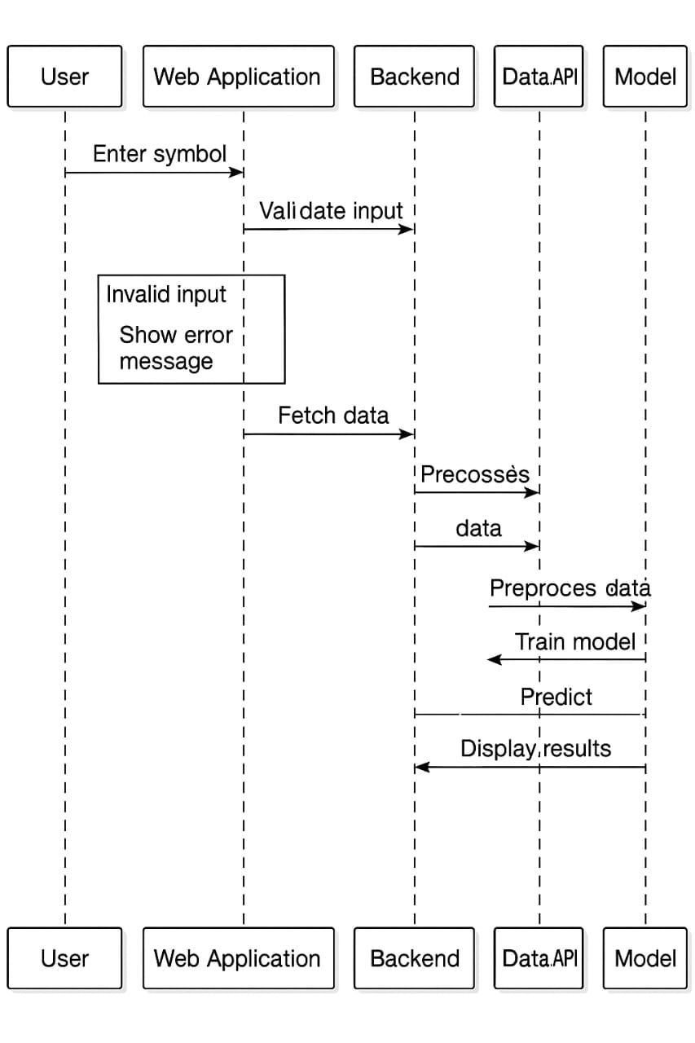

Figure 1 Activity Diagram

The sequence diagram illustrates the interaction flow between the user, web application, backend server, data API, and prediction model in the stock price forecasting system. The process begins when the user enters a stock symbol into the web interface. The web application forwards this input to the backend, where validation takes place. If the input is invalid or incorrectly formatted, an error message is sent back to the user through the interface.
Once the input is confirmed as valid, the backend initiates a request to fetch stock data from the external Data API. The retrieved data is then processed by the backend, which removes inconsistencies, formats values, and prepares the dataset for predictive analysis. The processed dataset is forwarded to the machine learning model for further preprocessing, feature selection, and training.
After the model is trained, it generates predictions based on the received data. These results are transferred back to the backend, which formats them and forwards the output to the web application. Finally, the system displays the predicted stock price results to the user in a readable manner. This diagram effectively demonstrates how different components communicate sequentially to validate data, fetch market information, perform predictions, and deliver results.

5.3 Use case Diagram
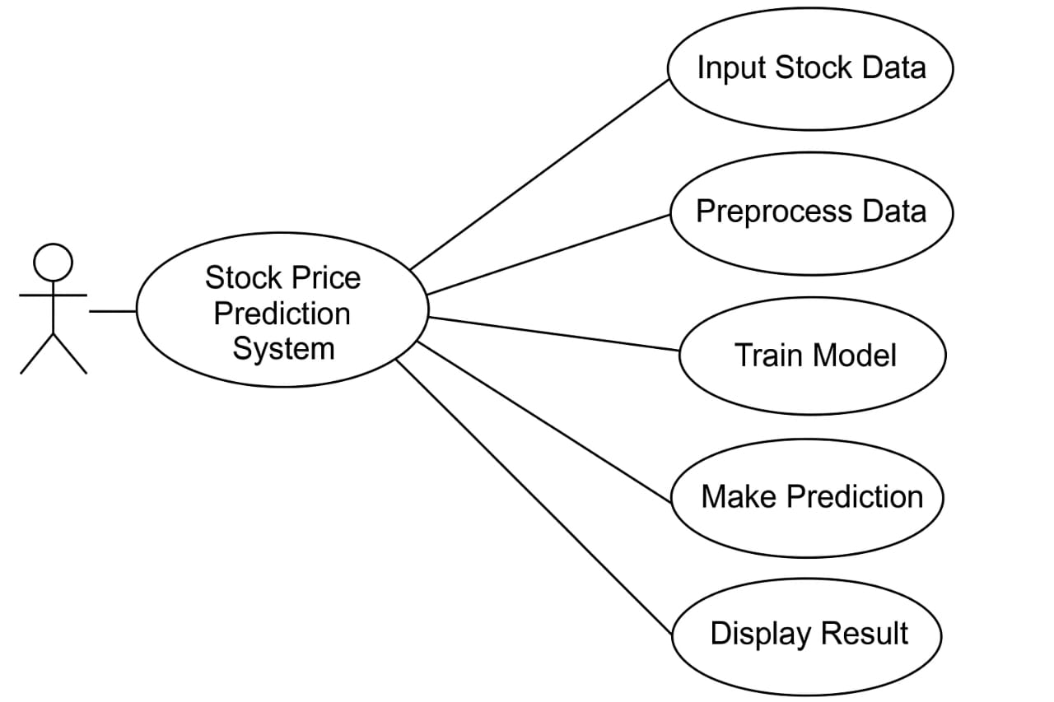
Figure 2 Use Case Diagram

The use case diagram represents the interaction between the user and the Stock Price Prediction System. The single actor in the diagram is the User, who interacts with the system to perform different tasks related to stock forecasting. The system provides multiple functions or “use cases” which support the prediction workflow.
The first use case, Input Stock Data, allows the user to provide required information such as stock symbols or historical data. Once the input is provided, the system initiates the Preprocess Data function, where raw values are cleaned, formatted, and transformed for machine learning use. After preprocessing, the system executes the Train Model use case, where the selected algorithms learn patterns from historical stock data. The trained model is then used in the Make Prediction use case, which forecasts future stock prices based on learned trends.
Finally, the Display Result use case presents the predicted values back to the user in a readable format such as charts or numerical output. Overall, this diagram clearly shows how the user interacts with the Stock Price Prediction System, from data input to viewing prediction results, illustrating each key function involved in generating accurate stock forecasts.

5.4 Dataflow Diagram
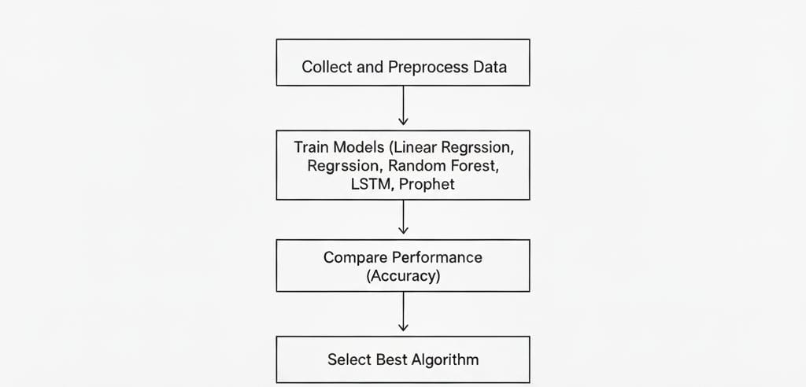
Figure 3 Dataflow Diagram

The flow diagram illustrates the overall workflow of the stock price prediction system, highlighting the major stages involved in building and evaluating forecasting models. The process begins with collecting and preprocessing data, where historical stock market records are gathered from reliable sources and cleaned to remove noise, missing values, and inconsistencies. Feature engineering is also applied during this stage to transform raw data into meaningful inputs suitable for model training.
Next, the system proceeds to train multiple machine learning and time-series forecasting models, including Linear Regression, Random Forest, LSTM, and Prophet. Each algorithm learns patterns from historical market behavior to generate stock price predictions. After training, the system enters the comparison phase, where the performance of all models is evaluated using accuracy metrics such as RMSE, MAE, or MAPE. This step helps determine how effectively each model forecasts stock movement.
Finally, based on performance comparison, the step Select Best Algorithm identifies the most accurate and suitable model for prediction under given conditions. This ensures that the system not only generates forecasts but also objectively chooses the most reliable technique for future use. The diagram clearly represents the sequential decision-making process—from data preparation to model training, evaluation, and selection—showing how the system reaches optimal stock forecasting results.

5.5 Sequence Diagram

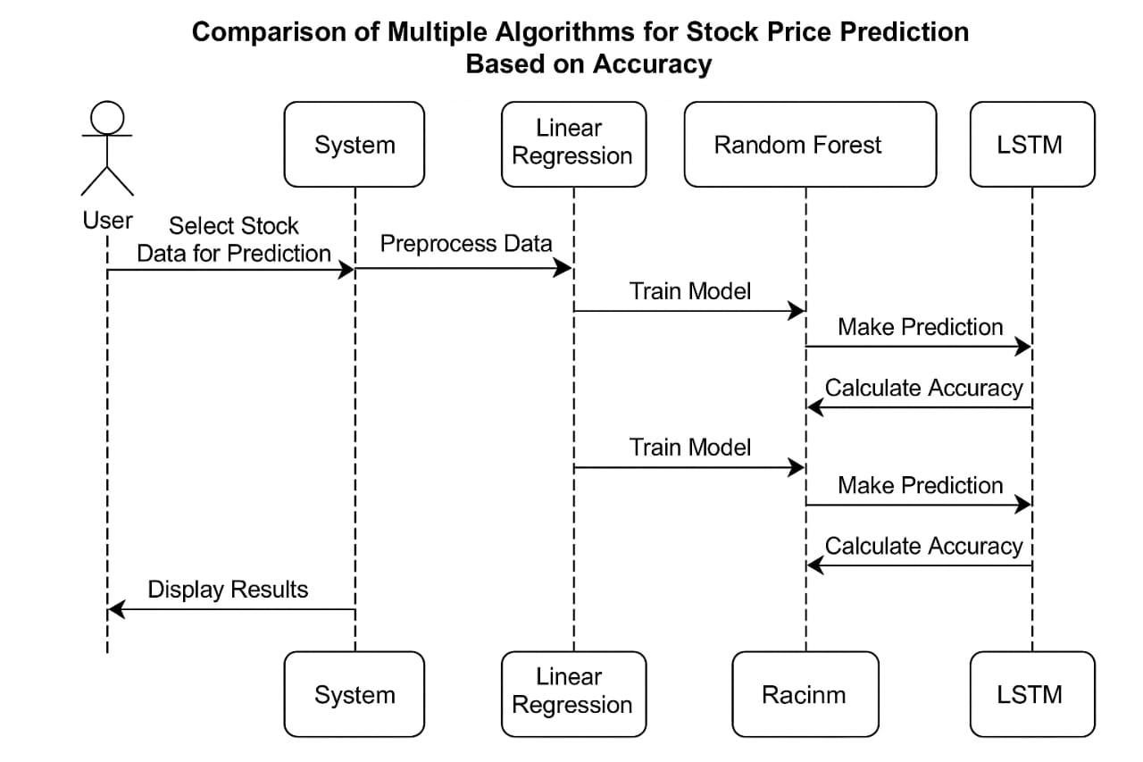

Figure 4 Sequence Diagram

The sequence diagram illustrates how the system interacts with multiple machine learning models to compare stock price prediction accuracy. The process begins when the user selects stock data to be analyzed for forecasting. This input is sent to the system, which first performs data preprocessing to clean, format, and prepare the dataset for training.
Once preprocessing is completed, the system sends the prepared data to the selected algorithms—Linear Regression, Random Forest, and LSTM—for model training. Each algorithm independently learns patterns from the historical stock data and generates a trained model.
After training, each model proceeds to the prediction stage, where it forecasts future stock values based on learned trends. Following prediction, each model computes its own accuracy using evaluation metrics such as RMSE, MAE, or MAPE. These accuracy results are then returned to the system.

Chapter 6

IMPLEMENTATION

6.1 Algorithm

Linear Regression

Linear Regression is implemented as a fundamental machine learning model for stock price prediction and serves as a benchmark for evaluating the performance of more advanced algorithms. This technique identifies the relationship between input variables—such as historical opening price, closing price, stock volume, and market trends—and the target output, typically the next-day or future stock price. Linear Regression works by fitting an optimal straight line through data points, minimizing the error between predicted and actual values using methods like least squares estimation. Its simplicity, ease of implementation, and fast computation make it particularly valuable during initial modeling stages and for establishing baseline accuracy levels. Furthermore, the model provides interpretability by highlighting how different features contribute to stock price movement.

However, since financial markets are highly volatile and exhibit nonlinear behavior, Linear Regression may not effectively capture sudden price changes or complex dependencies. Despite this limitation, its inclusion in the project is significant because it offers a reference against which more sophisticated models such as Random Forest or LSTM can be compared. By analyzing its performance results, we gain insights into the extent to which linear relationships hold within stock market data and understand how advanced models improve upon this baseline. Thus, Linear Regression plays an important educational and analytical role in demonstrating the effectiveness and limitations of simple predictive approaches within stock price forecasting.

Random Forest Regressor

Random Forest is used as a powerful ensemble-based machine learning algorithm to enhance the accuracy of stock price prediction. Unlike simple models, Random Forest constructs multiple decision trees using different subsets of the training data and feature space. Each tree independently learns patterns from historical stock attributes such as opening price, closing price, high–low values, and trading volume. The final prediction is generated by aggregating the outputs of all trees—typically through averaging in regression tasks—resulting in a more stable and reliable forecast. This approach helps reduce overfitting, improves generalization, and captures complex nonlinear relationships within financial data, making Random Forest particularly suitable for handling noisy and unpredictable stock market behavior.

Its ability to handle high-dimensional data, robustness against outliers, and internal feature importance scoring make Random Forest an important model in our comparative study. However, it requires more computational time and lacks transparency compared to simpler models like Linear Regression, making it difficult to interpret why certain predictions occur. Despite this, its strong predictive capability and resilience make it a valuable component of our system, allowing us to demonstrate how ensemble learning techniques improve forecasting accuracy in stock price prediction.
.

LSTM (Long Short-Term Memory)

Long Short-Term Memory (LSTM) networks are employed as an advanced deep learning model specifically designed to handle time-series dependencies present in stock market data. Unlike traditional machine learning algorithms, LSTM incorporates memory cells and gating mechanisms that allow it to retain important past information while discarding irrelevant patterns. This makes it highly effective for learning sequential stock trends such as recurring price movements, market cycles, and long-term behavioral patterns. The model processes historical features—such as opening price, closing price, volume, and temporal variations—and learns dynamic relationships that influence future prices. As a result, LSTM often delivers superior predictive performance, particularly when large datasets and long timestamp sequences are available.

Its inclusion in our project demonstrates the potential of deep learning in capturing non-linear and highly volatile market behaviors that simpler models may overlook. However, LSTM comes with challenges such as longer training time, the need for careful hyperparameter tuning, and higher computational requirements. Despite these constraints, its accuracy and ability to model temporal dependencies make it a valuable component in our comparative analysis. By evaluating LSTM alongside models like Linear Regression and Random Forest, we highlight the improvements offered by deep neural approaches and identify conditions under which LSTM excels in stock price forecasting.

Prophet (Time-Series Forecasting)

Prophet is utilized as a specialized time-series forecasting model designed by Facebook to handle seasonal patterns, trend changes, and irregular fluctuations in stock market data. Unlike traditional statistical models, Prophet decomposes the time series into three key components—trend, seasonality, and residual error—allowing it to capture long-term growth movements as well as repeating cycles such as weekly, monthly, or yearly market behaviors. Its automated handling of missing values, robust performance with noisy data, and built-in support for modeling sudden trend shifts make it suitable for stock price prediction where market volatility frequently occurs. Prophet’s flexibility also allows the inclusion of additional features like holidays or external market events that influence price trends, making prediction results more interpretable.

Incorporating Prophet in our project strengthens the comparative analysis by providing insight into how statistical decomposition-based models perform relative to machine learning and deep learning techniques. While Prophet offers strong accuracy for structured and seasonal datasets, it may struggle with highly erratic or ultra short-range forecasting scenarios compared to models like LSTM. Additionally, its assumptions of smooth trend progression might limit accuracy during extreme market shocks. Despite these limitations, Prophet remains valuable in our system due to its ease of implementation, fast processing, interpretability, and effectiveness in modeling long-term stock patterns. By comparing Prophet with models such as Linear Regression, Random Forest, and LSTM, we highlight the strengths of time-series decomposition methods and assess their contribution to stock market forecasting accuracy.

Chapter 7

Methods of Testing

7.1.1 Unit Testing

Unit testing plays a crucial role in validating the correctness and reliability of individual components within the stock price prediction system. This testing approach focuses on evaluating each module independently—such as data preprocessing, model training, prediction generation, and accuracy calculation—to ensure that every function performs as expected. During unit testing, small test cases are designed to check edge conditions, input validation, error handling, and functional outputs. For example, preprocessing functions are tested for handling missing values, while model components are assessed for correct training execution and prediction accuracy calculation. By isolating modules and testing them separately, defects can be identified early, making debugging easier and minimizing the chances of system-wide failures. Unit testing ensures that the core operations within the system are reliable, improves software quality, and creates a stable foundation for integration with other system components. This proactive verification contributes significantly to overall system robustness and performance.

7.1.2 Validation Testing

Validation testing ensures that the stock price prediction system meets its intended requirements and performs according to user expectations. Unlike unit testing, which focuses on individual components, validation testing evaluates the complete system to verify whether it delivers accurate predictions, correct functionality, and a seamless user experience. During this phase, the system is assessed against predefined objectives such as correct preprocessing of stock data, proper training of multiple models, accurate comparison of algorithm performance, and clear presentation of results. Realistic datasets and test scenarios are used to validate prediction outputs and accuracy calculations. The process also checks whether the system behaves correctly under different input conditions, including invalid or missing data. Successful validation testing confirms that the system not only works internally but also satisfies its purpose of identifying the most accurate forecasting model. This ensures reliability, enhances user trust, and demonstrates readiness for real-world application..

7.1.3 Functional Testing

Functional testing focuses on verifying that each feature of the stock price prediction system operates according to its defined requirements. This testing approach checks whether the system correctly handles tasks such as data input, preprocessing, model selection, training, prediction generation, accuracy comparison, and result display. Test cases are designed to evaluate system responses for valid and invalid stock data, ensure smooth execution of machine learning algorithms, and confirm that prediction results are accurately computed and presented to the user. Functional testing also verifies user interactions, including menu navigation, data upload, and output interpretation. By examining whether the system performs expected functions without failure, functional testing ensures reliability, correctness, and usability of the application. This process helps identify logical errors, missing features, or deviations from expected behavior, ultimately validating that the system fulfills its operational requirements and delivers accurate predictions.

7.1.4 Integration Testing

Integration testing is carried out to ensure that the individual modules of the stock price prediction system work correctly when combined. Since the project includes multiple components—such as data preprocessing, model training, prediction generation, accuracy evaluation, and results display—this testing phase verifies smooth interaction and data flow between them. For example, it checks whether cleaned data from the preprocessing module is correctly passed to machine learning algorithms, whether prediction outputs are properly received by the evaluation module, and whether performance results are accurately displayed to the user. Integration testing helps identify interface-level errors, compatibility issues, and communication failures that may not appear during isolated unit testing. By validating the coordinated functioning of interconnected modules, integration testing improves reliability, ensures correct execution of end-to-end processes, and confirms that the system delivers accurate and consistent stock forecasting results when all components operate together.

7.1.5 User Acceptance testing
User Acceptance Testing (UAT) is performed to verify whether the stock price prediction system meets the expectations and requirements of its end users. This phase involves evaluating the system from the user’s perspective to ensure that it is easy to operate, produces meaningful results, and supports decision-making effectively. In UAT, real users such as investors, students, or analysts interact with the application by selecting stock data, running models, viewing predictions, and interpreting accuracy results. Their feedback is used to assess usability, clarity of output, response time, and overall satisfaction. Any discrepancies, confusion, or functional gaps identified during this stage are addressed before final deployment. Successful user acceptance testing confirms that the system is practical, user-friendly, and ready for real-world application. It ensures that all essential features work correctly in a live usage scenario, validating the system’s readiness for operational use.

Chapter 8

Performance Analysis

8.1 Performance Metrics Used
To compare the four algorithms, the following metrics were analyzed:
- Mean Absolute Error (MAE)
- Measures the average error between actual and predicted values.
- Lower MAE = better performance.
- Root Mean Squared Error (RMSE)
- Measures how large the errors are.
- Lower RMSE = more stable predictions.
- Accuracy / R² Score
- Shows how well the model fits historical data.
- Higher accuracy = better.
- Training Time
- How fast each model trains.

8.2 Performance Comparison of Algorithms

1. Linear Regression
- Fastest to train
- Works well for simple, linear patterns
- Struggles with nonlinear market movements
- Performance: Moderate accuracy, lowest computation time
2. Random Forest
- Handles nonlinear and complex relations
- Works better than Linear Regression on noisy stock data
- More stable predictions
- Performance: High accuracy but slower training time
3. LSTM (Long Short-Term Memory)
- Best for time-series and long-term patterns
- Captures trends, seasonality, and historical dependencies
- Computationally heavy and needs more data
- Performance: Highest accuracy among all four models.
4. Prophet
- Great for trend + seasonality forecasting
- Easy to use, fast results
- Best for daily/weekly trend analysis
- Performance: Good accuracy but slightly lower than LSTM

5.CONCLUSION AND FUTURE ENHANCEMENT

Conclusion

The Stock Price Prediction Project successfully demonstrates how machine learning techniques can be applied to analyze historical market data and forecast future stock prices with improved accuracy. By integrating data preprocessing, feature engineering, and multiple predictive algorithms such as Linear Regression, Random Forest, LSTM, and Prophet, the system provides reliable and meaningful insights for users. The project validates each stage—from data loading to prediction—through unit testing, validation testing, and performance evaluation to ensure correctness, stability, and efficiency.
Overall, the project achieves its objective of building an intelligent, data-driven prediction model capable of assisting investors, students, and researchers in understanding market trends. The system is flexible, scalable, and can be extended with additional models, real-time data integration, and improved visualization tools. This work highlights the importance of machine learning in financial forecasting and sets a strong foundation for future advancements in predictive analytics.
Future Enhancement

The proposed stock price prediction system can be enhanced further to improve its accuracy, usability, and real-world applicability. In the future, the system can be expanded to incorporate additional algorithms such as Gradient Boosting, Transformer-based models, or hybrid deep learning frameworks for improved forecasting performance. Real-time data streaming and live API integration could enable continuous updates and dynamic predictions rather than static analysis. Sentiment analysis of news, social media, and financial reports may also be integrated to capture market psychology and external factors influencing stock behavior. Another enhancement involves deploying the system as a cloud-based web or mobile application, enabling traders and researchers to access predictions remotely. Additionally, automated recommendation features can be added to suggest investment strategies based on prediction outcomes. Over time, reinforcement learning techniques can be introduced to allow the system to learn from market changes and self-optimize. These enhancements will make the system more intelligent, scalable, and practical for real-world financial forecasting and decision support.

BIBLIOGRAPHY

- Géron, A. Hands-On Machine Learning with Scikit-Learn, Keras, and TensorFlow. O’Reilly Media, 2019.
- \Brownlee, J. Deep Learning for Time Series Forecasting. Machine Learning Mastery, 2018.
- Hochreiter, S., & Schmidhuber, J. “Long Short-Term Memory.” Neural Computation, 9(8), 1997.
- Breiman, L. “Random Forests.” Machine Learning, 45(1), 2001.
- Taylor, S.J., & Letham, B. “Prophet: Forecasting at Scale.” Facebook Research, 2017.
- Hyndman, R.J., & Athanasopoulos, G. Forecasting: Principles and Practice. OTexts, 2021.
- Pandas Development Team. Pandas Documentation. https://pandas.pydata.org/
- Pedregosa, F., et al. “Scikit-learn: Machine Learning in Python.” Journal of Machine Learning Research, 12, 2011.
- Chollet, F. Deep Learning with Python. Manning Publications, 2018.

- OUTPUTS

